Lahore Garrison University
DHA Phase 6 Lahore



Student Name | Muneeb Ur Rehman
Student Roll No | Fa23/BSCS/490
Section | D
Subject | Web Technology
Instructor Name | Mr. Muhammad Yousaf

Step 1: Style the Personal Portfolio
HTML File (index.html) – Basic Structure
<!DOCTYPE html>
<html lang="en">
<head>
<meta charset="UTF-8">
<meta name="viewport" content="width=device-width, initial-scale=1.0">
<title>Muneeb Portfolio</title>
<link rel="stylesheet" href="style.css">
</head>
<body>
<header>
<h1>Muneeb Ur Rehman</h1>
<p>Web Developer | Robotics Enthusiast</p>
</header>
<nav>
<a href="#about">About</a>
<a href="#skills">Skills</a>
<a href="#projects">Projects</a>
<a href="#contact">Contact</a>
</nav>
<section id="about">
<h2>About Me</h2>
<p> Hello! I’m Muneeb — passionate about web development and robotics. I love combining creativity and logic to make smart projects. </p>
</section>
<section id="skills">
<h2>Skills</h2>
<ul>
<li>HTML</li><li>CSS</li><li>JavaScript</li>
<li>Python</li><li>C++</li><li>Robotics</li>
</ul>
</section>
<section id="projects">
<h2>Projects</h2>
<div class="project">
<h3>Line-Following Robot</h3>
<p>PID-controlled robot using IR sensors.</p>
</div>
<div class="project">
<h3>Portfolio Website</h3>
<p>My personal responsive portfolio built with HTML & CSS.</p>
</div>
</section>
<section id="contact">
<h2>Contact</h2>
<p>Email: <a href="mailto:mu9eeb1397@gmail.com">mu9eeb1397@gmail.com</a></p>
<p>GitHub: <a href="https://github.com/muneeb" target="_blank">github.com/muneeb</a></p>
</section>
<footer>
<p>© 2025 Muneeb Ur Rehman | Made with 💙</p>
</footer>
</body>
</html>

CSS File (style.css) – Styling and Box Model
body {
font-family: Arial, sans-serif;
margin: 0;
background: #f5f8ff;
color: #222;
text-align: center;
}
header {
background: #0078d7;
color: white;
padding: 2rem 1rem;
}
nav {
background: #eee;
padding: 0.8rem;
}
nav a {
margin: 0 1rem;
color: #0078d7;
text-decoration: none;
font-weight: bold;
}

nav a:hover {
color: #ffb400;
}
section {
background: white;
margin: 1.5rem auto;
padding: 1.5rem;
max-width: 600px;
border-radius: 10px;
box-shadow: 0 0 10px rgba(0,0,0,0.1);
}
ul {
list-style: none;
padding: 0;
}
.project {
margin: 1rem 0;
}
footer {
background: #0078d7;
color: white;
padding: 1rem;
margin-top: 2rem;
}
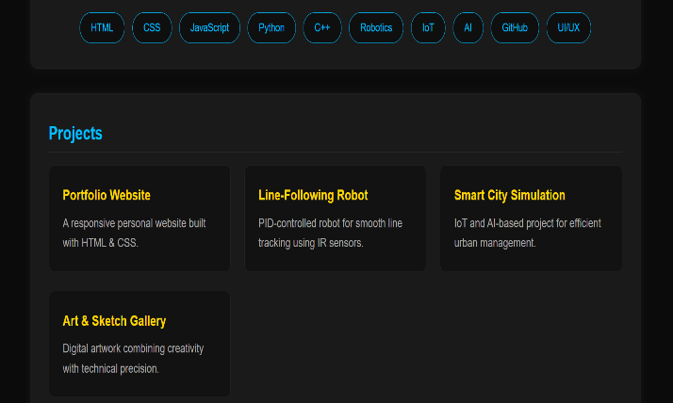
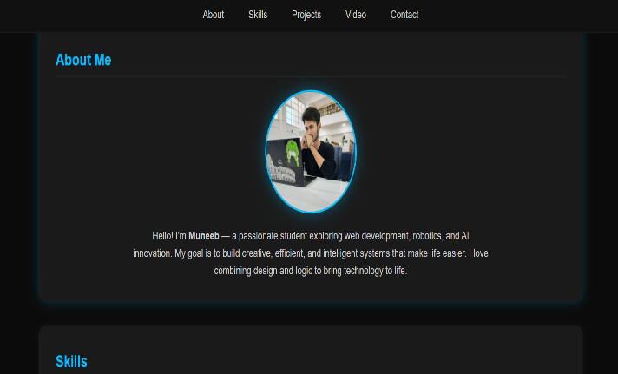
Conclusion:
ID and class selectors enable precise and reusable styling for specific elements, enhancing design control and consistency. Descendant selectors support contextual styling within parent elements, improving structure and readability. While float and clear were traditional layout techniques, modern approaches like Flexbox and Grid offer more flexible and responsive design solutions. Additionally, media queries ensure adaptability across various screen sizes, resulting in a clean, responsive, and well-structured web page that is both efficient and easy to maintain.

